Test Paper No _____

APPLECROSS SENIOR HIGH SCHOOL

3A 3B HUMAN BIOLOGICAL SCIENCE

DO NOT MARK THIS TEST PAPER IN ANY WAY

Time allowed: 30 minutes.

Answer questions 1 to 30 on the multiple choice answer sheet. Follow the instructions on the answer sheet.

___________________________________________

1. The following diagram shows the regulation of carbon dioxide concentration in arterial blood.

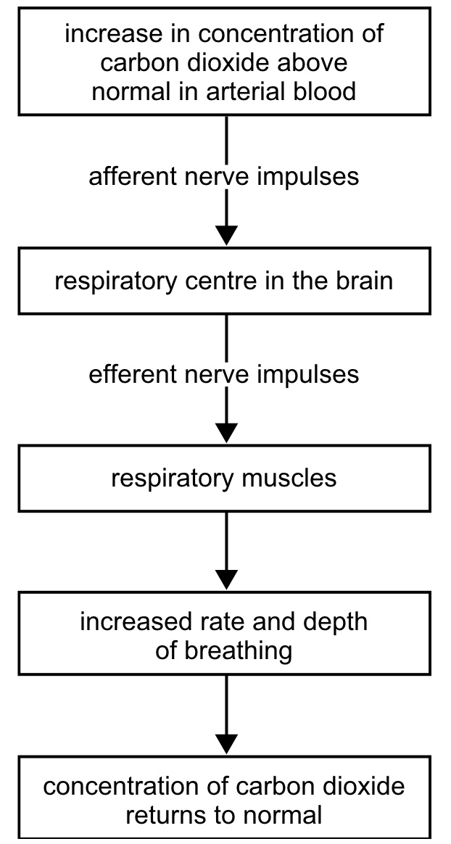

The effector in the regulation of carbon dioxide concentration is the:

a) respiratory muscles.
b) efferent nerve impulses.
c) respiratory centre in brain.
d) afferent nerve impulses.

2. Which of these statements is NOT true regarding the temperature regulation function of the skin?

a) As sweat evaporates from the skin, it carries away heat and drops body temperature.
b) When body temperature increases, blood vessels in the epidermis dilate to transfer heat to the skin.
c) The skin can lose heat by radiation, conduction, evaporation, or convection.
d) If skin temperature falls below 10°C, blood vessels in the skin dilate.

3. According to the sliding ﬁlament mechanism of skeletal muscle contraction, during contraction:

a) The thick ﬁlaments stay the same size but the thin ﬁlaments shorten.
b) The sarcomeres shorten.
c) The thin ﬁlaments stay the same size but the thick ﬁlaments shorten.
d) Both thick and thin ﬁlaments shorten.

4. The basic structural and functional unit of skeletal muscle is the

a) ﬁbre
b) fascicule
c) myoﬁbril
d) sarcomere

5. Actin myoﬁlaments

a) are attached to the Z line.
b) are found primarily in the H zone.
c) are thicker than myosin myoﬁlaments.
d) all of the above

6. When a person moves their arm from A to B as shown in the diagram below:
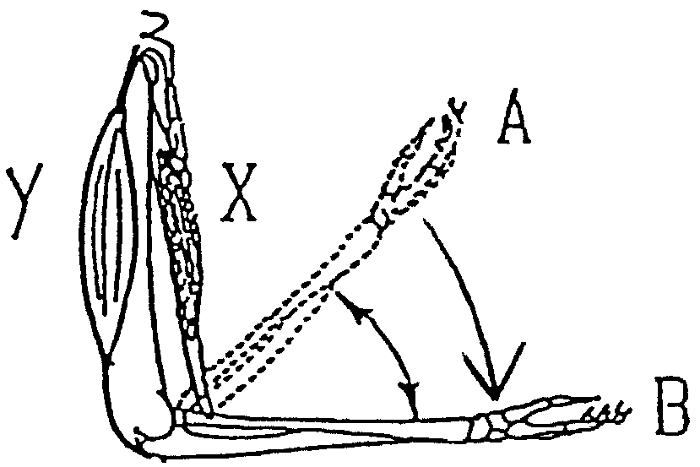

a) muscles X and Y both contract
b) muscle X contracts and muscle Y relaxes
c) muscle X relaxes and muscle Y contracts
d) muscle X and Y both relax

7. _________________ regulates the kidney's retention of water. Its secretion is suppressed by alcohol.

a) prolactin
b) oxytocin
c) thyroxine
d) antidiuretic hormone

8. Which of the following hormones raises the blood sugar level?
a) glucagon
b) oxytocin
c) insulin
d) antidiuretic hormone

9. Which grouping of muscle constituents is listed correctly in descending order of size?

a) myoﬁbril, muscle ﬁbre, myoﬁlament
b) muscle ﬁbre, myoﬁbril, actin-myosin, myoﬁlament
c) muscle fibre, myoﬁbril, myoﬁlament
d) muscle ﬁbre, myoﬁbril, myoﬁlament, actin-myosin

10. What is the name of the region of the brain that controls body temperature?

a) Medulla Oblongata
b) Hypothalamus
c) Pituitary gland
d) Meninges

11. Which of the following is NOT a function of muscle?

a) Maintaining posture
b) Movement
c) Generating heat
d) Producing red blood cells

12. When the concentration of carbon dioxide returns to normal it would be reasonable to conclude that the

a) respiratory muscles stop contracting.
b) rate and depth of breathing decreases.
c) number of afferent nerve impulses increase.
d) respiratory centre in the brain fails to send efferent nerve impulses.

13. Yellow bone marrow

a) provides internal support to spongy bone
b) is found only in lower vertebrates
c) produces red blood cells
d) stores fat

14. Which type of muscle is labelled III in the Venn diagram shown

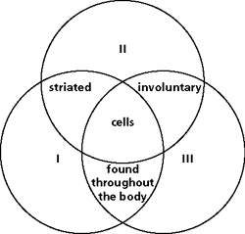

a) smooth
b) ﬁlament
c) skeletal
d) cardiac

15. Movement at a joint away from the midline is known as _____________, and movement towards the midline is _____________.

a) ﬂexion; extension
b) extension; ﬂexion
c) adduction; abduction
d) abduction; adduction

16. Bones are covered with a dense white connective tissue called _________________.

a) diaphysis
b) endosteum
c) periosteum
d) epiphysis

17. Which of these is NOT a normal function of the skeleton?

a) mineral storage
b) protection of underlying tissues
c) production of red blood cells
d) All of these are functions of the skeleton.

18. Each osteon contains:

a) lamellae
b) a central canal
c) osteocytes in lacunae.
d) all of these

19. Cancellous bone

a) has no osteocytes.
b) is mainly located in the diaphyses of long bones.
c) is composed of delicate interconnecting rods or plates.
d) has spaces filled with marrow.

20. Straightening your arm to point at something straight ahead of you involves

a) abduction of the arm.
b) adduction of the arm.
c) circumduction of the arm.
d) extension of the arm.

21. What is the name of the attachment that binds one bone to another?

a) ﬁlament
b) joint
c) tendon
d) ligament

22. A good example of a positive feedback mechanism would be

a) body temperature regulation.
b) regulating glucose levels in the blood.
c) enhancement of labor contractions by oxytocin.
d) blood calcium level regulation.

23. For long-term storage, glucose is converted to ______ , while for short-term storage, glucose is converted to ______.

a) fat, glycogen
b) glycogen, protein
c) pyruvic acid, fat
d) fat, pyruvic acid

24. The _____ represent the cracks in bone tissue that directly supply nutrients to the osteocytes.

a) canaliculi
b) lamellae
c) osteons
d) Haversian canals

25. The shoulder and hip joints are of this type.

a) ball-and-socket
b) pivot
c) saddle
d) gliding

26. The type of joint that is distinguished by having a fluid-filled joint cavity is a ______________ joint.

a) ﬁbrous
b) cartilaginous
c) synovial
d) suture

27. Within certain synovial joints, fibrous cartilaginous pads, called ______________, cushion and guide the articulating bones.

a) articular cartilages
b) bursae
c) synovial membranes
- menisci

28. The greatest range of motion is provided by the

a) pivot joint
b) ball-and-socket joint
c) saddle joint
d) condyloid joint

29. Which one of the following body joints is bathed in synovial fluid?

a) plates of bone that make up the skull
b) tooth sockets.
c) between the third rib and the sternum.
d) between finger phalanges

30. The joints between the phalanges are ________ joints.

a) gliding
b) hinge
c) pivot
d) condyloid

